Project Design Phase
Proposed Solution

Date | 2 November 2025
Team ID | NM2025TMID01022
Project Name | Streamlining Ticket Assignment for Effective Support System
Maximum Marks | 2 Marks

Proposed Solution Template:
S.No. | Parameter | Description
1. | Problem Statement (Problem to be solved) | In many support systems, tickets are manually assigned, leading to uneven workload distribution, slower response times, and decreased efficiency..
2. | Idea / Solution description | An automated rule-based system is developed to streamline ticket assignment. It analyzes factors such as ticket priority, agent workload, and skill level to automatically assign tickets.
3. | Novelty / Uniqueness | It eliminates manual intervention, ensures fair task distribution, and improves SLA compliance without relying on external plugins or complex AI modules.
4. | Social Impact / Customer Satisfaction | It ensures better accountability and reliability for IT support teams, avoiding mistakes that lead to process breakdowns.
5. | Business Model (Revenue Model) | Not applicable directly, but can save time, reduce data corruption, and avoid miscommunication — leading to cost-effective  ITSM operations for companies.
6. | Scalability of the Solution | The solution can be extended to include other modules like Change Requests or Problem Tickets. It can also be adapted for role-based restrictions in large teams.

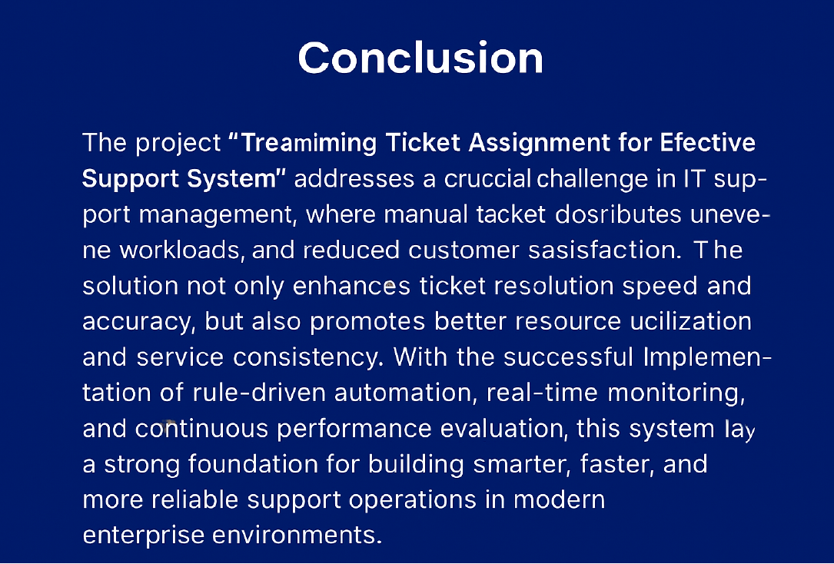Reference: Infographic created using MidJourney.
Solution Description:
The project “Streamlining Ticket Assignment for Effective Support System” aims to automate and optimize the ticket distribution process in IT support environments. The solution uses rule-based logic to evaluate ticket parameters such as category, priority, and agent workload before automatically assigning them to the appropriate support personnel

